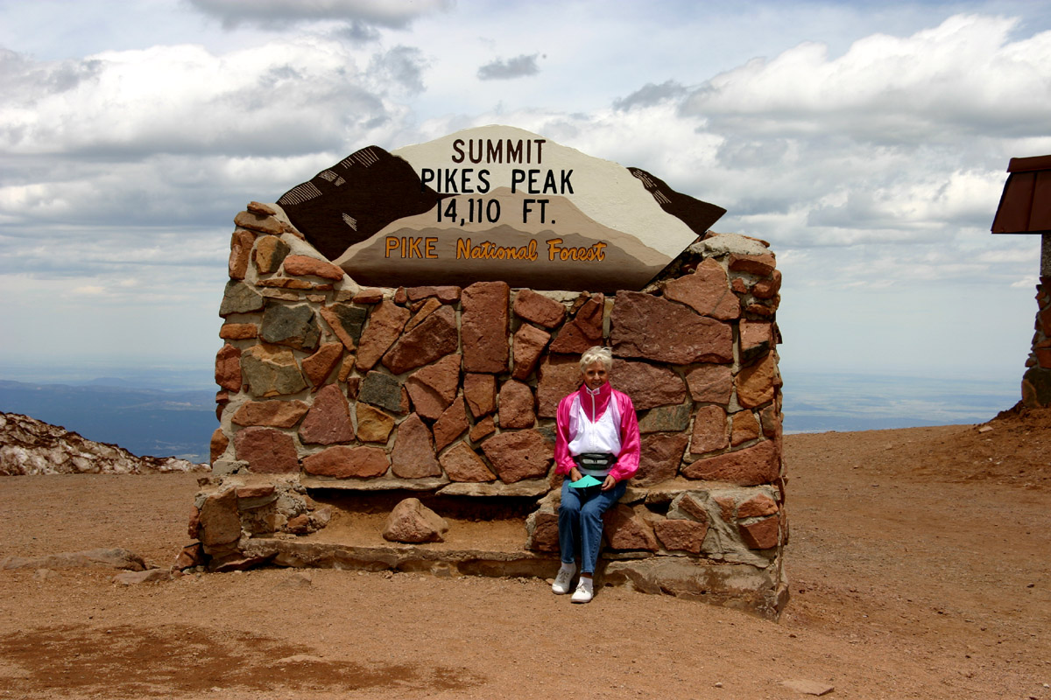
Image 5263: At 14,110 feet, sitting down is a good idea! I felt the altitude enough to become short of breath, though Maren seemed to do well with it. We were on the peak about 45 minutes before the train departed for the lowlands again.
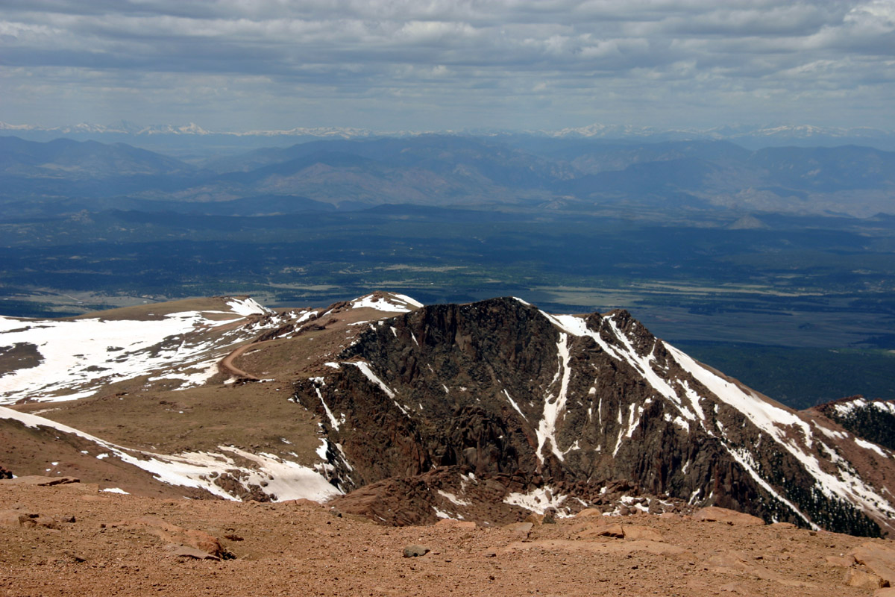
Image 5268: View Northeast, Along the Pike's Peak Automotive Road.
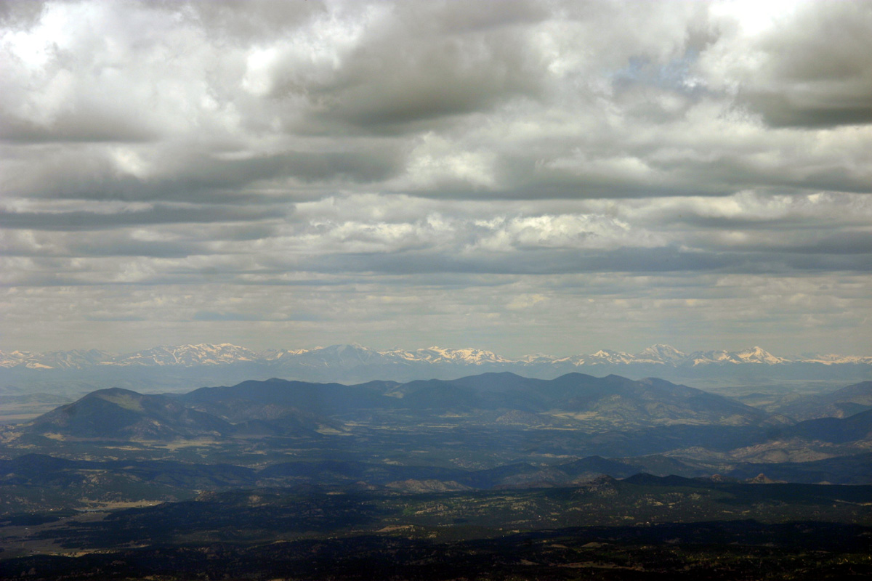
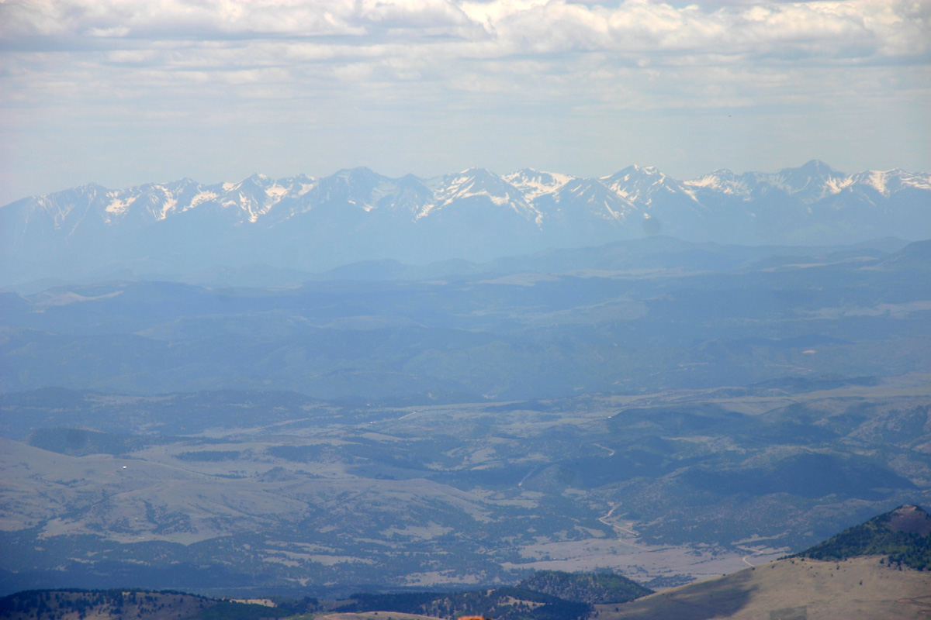
Image 5271, 5280: Snow-Capped Sangre de Christo Mountains, West of Pike's Peak.
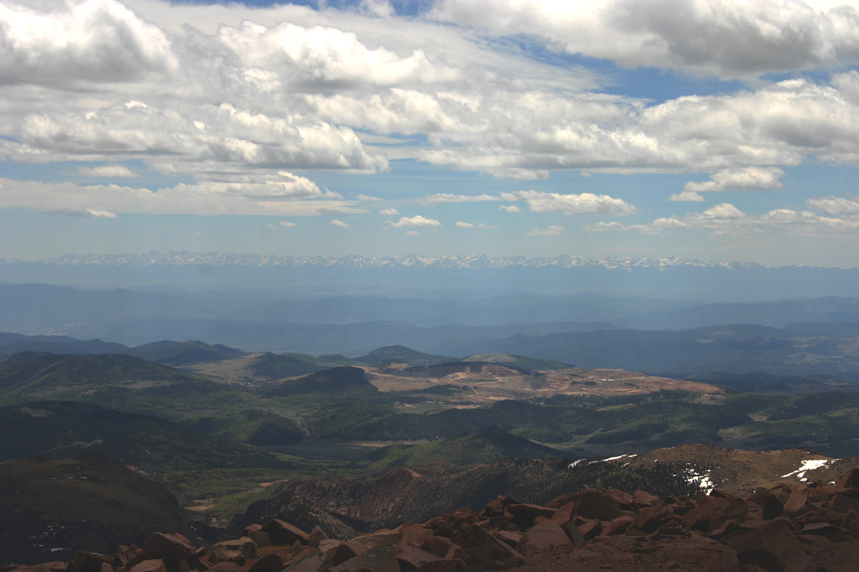
Image 5283: The terraced mountainside slightly to the right of center frame is an active gold mine, from which $5 Million dollars per week in gold is extracted.
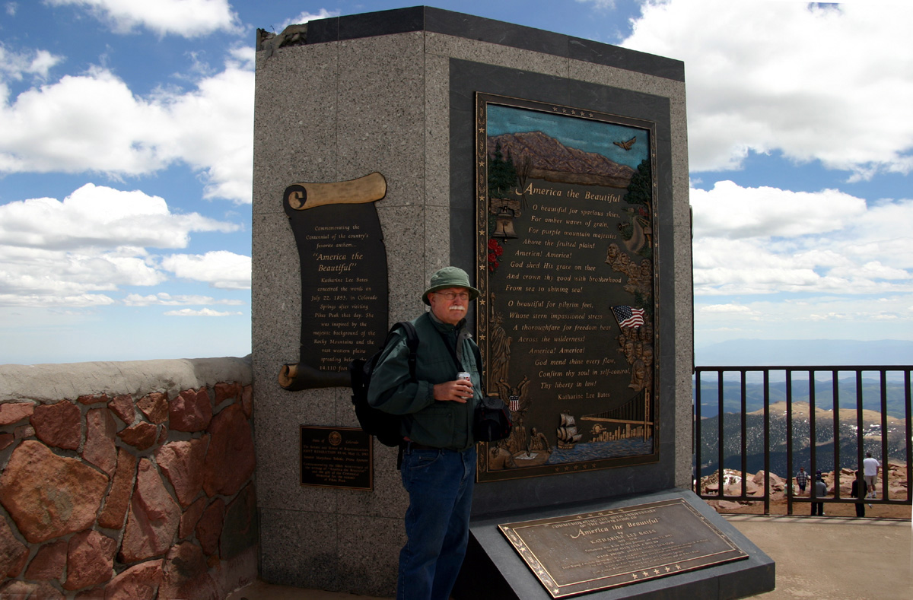
Image 5288: The monument celebrates the inspiration of the author of "America the Beautiful", composed at a spot nearby.
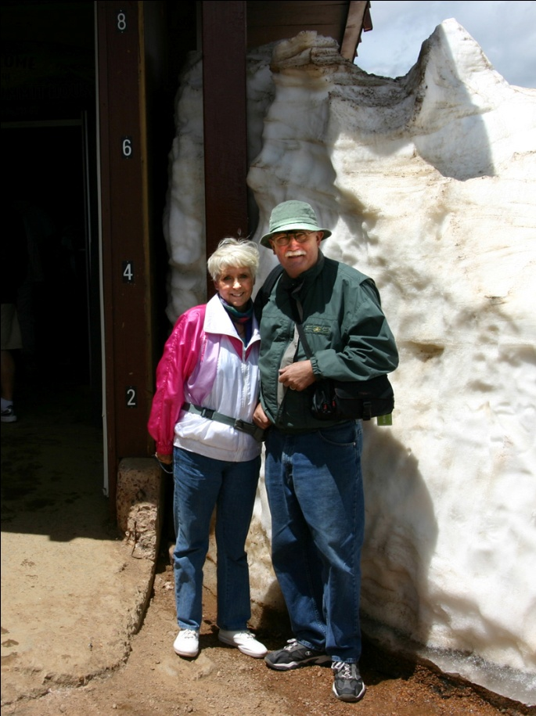
Image 5297: The height of this snowdrift (on June 3!) might suggest the winter conditions which prevail at the summit of Pike's Peak.
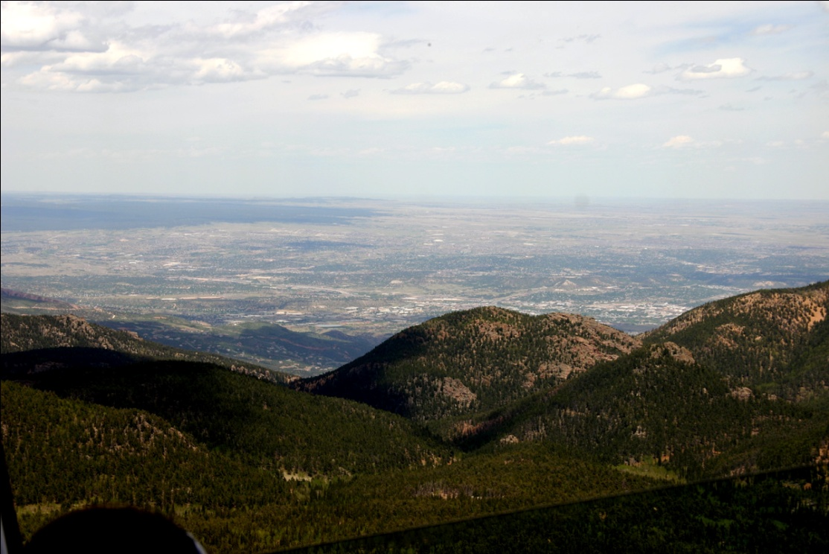
Image 5330: View of Colorado Springs and Points East.
It's said that “on a clear day you can see (not quite) forever” from up here. Our train conductor related that the visible horizon in clear weather is about 300 miles. Small wonder this Peak became a landmark for wagon trains making their way across the almost featureless high prairie.
Day 31: Saturday June 5 -- Colorado Springs to Salina Kansas (404 miles)
When we broke camp in Colorado Springs, we were anticipating a relatively dull few days of driving, on our way home from the neck-cricking heights and vast expanse of the American West and Southwest. From a photographic standpoint, our route indeed proved to offer relatively slim pickings. But there was another learning experience waiting for us.
In these five days when my eye was not so frequently behind the viewfinder of my Canon digital camera, Maren and I talked a lot about things we had observed during the five weeks of our American Journey. We realized that we had done much more than just “see” the remarkable scenery in the National Parks or the American West. We had also been exposed to some remarkable polarities in America as a country and as a culture.
Our drive from Colorado Springs to slightly east of the middle of Kansas started out on a rural stretch of US Highway 24 and then joined Interstate 70 at Limon, Colorado. This section of the country seemed to be a familiar if somewhat greener version of the high prairie in western Oklahoma and the Texas Panhandle. It is also a land rich in names that Americans recognize without full awareness of why we do, or in what manner the names have come to be in the American historical vocabulary.
At various distances to the north and south of our route, towns on the map display names that many people relate to the great Frontier and to American Indians of the late 19th century. Also represented are Anglo legends who contributed to a great mythology which sprang from the incredibly short 20 years that actually comprised the “age of the cowboy” – before the technology of barbed wire and windmills forever changed the landscape and the manner in which its inhabitants earned their often-meager living.
The map hinted of places and experiences popularized by film directors such as John Ford and actors such as John Wayne. Colorado towns named for “Wild Horse” and “Deer Trail” may have been preoccupations of “Kit Carson” (for whom another town is named in eastern Colorado). Indians are well represented in the naming of the land, if no longer in its dominant cultures: Kiowa, Cheyenne Wells, and Arapahoe are all place names in this region, with close cousin-names such as Blackfoot and Shoshone further to the north.
As we drove eastward, we were often reminded that the American heartland has produced its share of larger than life figures and places. One town in Kansas was proud to announce its association with George Armstrong Custer -- which prompted quite an animated discussion as we drove along. As a student of the American Civil War, my normally civilized spouse tends to describe George in words a great deal less than publicly polite, starting with “arrogant jackass” and working down from there!
Abilene Kansas quietly announced its affiliation with the man whose vision was largely responsible for the beginnings of the American system of interstate highways: Dwight D. Eisenhower. His accomplishments as President and previously as a General were curiously dim in this public memorial. Several towns in Missouri are now pleased to be associated with the life and career of Harry S. Truman – though more than a few of those places had stronger reservations when the man worked in the Missouri Legislature and later in the Oval Office.
Finally, there were place names less specific but seemingly no less powerful. What was the significance of Lawrence Kansas? For that matter, why did Topeka so powerfully connect in my head that I found myself humming “The Atchison, Topeka and the Santa Fe” from “Chattanooga Choo-Choo”, for much of the next hour?
Much of America to the west of the Missouri and Mississippi Rivers is sparsely populated land. In one area of eastern Colorado this was demonstrated to us in an unexpected and perhaps ironic way. When I pressed the “seek” button of our FM radio, the receiver dutifully hunted its entire range for FM stations offering enough local signal to stop its search. Then it started over and did the task again... and again... You know you are in a kind of “wilderness” when you must tune each FM station by hand and listen carefully to winnow out announcers and music from the electronic noise background.
Where there were stations strong enough to be heard, some of the things we heard tended to vary more than a little from our city-bred experience. This was more than a matter of C&W or Rockabilly replacing Brahms and Chopin. In this wide open country of relatively few wealthy inhabitants, the contributor-support model of Public Broadcasting (PBS) seems not to work as well as in places where people are bunched together in urban areas. Instead of “All Things Considered”, you might pick up a rather heavy dose of that Old Time Religion. You can also pick your preferred variety of virulent anti-evolutionist rant, and find that it's probably out there. We heard local radio commentators who seemed to start where Rush Limbaugh leaves off.
The combination is enough to remind one that “necktie parties” and vigilante justice (or depending on one's circumstances, “injustice”) were historically seen more often in towns like Abilene or Dodge City Kansas, than in relatively staid Saint Louis, just a few hundred miles to the east.
I intuit that this contrast is more than one of merely historical traditions. Some contemporary writers go so far as to assert that Americans live not in one country but in two … or more... and that these different “Americas” are in competition for dominance in our culture and public life. To many students of history, Americans seem always to have been a people of contrasts. But this aspect of our national life seemed to be drawn much more visibly and sharply in the vast American Interior which we passed through on our American Journey.
One can see and hear a fair amount on CNN these days about the Tea Party movement. Despite the recent election results, some CNN and mainstream media stories still seem slanted toward discounting both the sentiments and potential political significance of the Tea Party folks. However, in Nevada, Idaho and Colorado, we saw local variations on the messages of the Tea Party activists. Some of the examples among those variants were a little hair raising!
For the first time I've seen in America, we encountered paid advertising on billboards that expressed an attitude similar to bumper stickers we've placed on our own vehicles: “No More Business as Usual! Throw the Bums Out!” This feels like something new to me: angry middle class citizens putting real money where their mouths are, rather than ineffectually grousing to friends in a neighborhood bar.
Individual citizens also prominently express their displeasure with American political affairs on their own (and doubtless sometimes others') property. In southwest Colorado, we drove past a utility trailer parked close to a State highway. The neatly lettered message on its side looked weathered enough to have been there for a while: “Obama the Liar – No Jobs, No SSI, No HOME!”
On a stretch of US 40 in Arizona, we sighted a deserted restaurant with gaping broken windows and wrecked gas pumps vandalized for their metal. On a wall of the building facing the highway could be read a scrawled message: “We once had a Business here. You can thank Obama and his Banker Friends on Wall Street that we went broke!”
(I paraphrase from memory, but believe the sentiment and tone to be accurate).
It's true enough that one can read or hear similar complaints on the Internet or in dressed-up language on newspaper editorial pages. And I'm uncertain anyone can say how “representative” any of these public expressions of exasperation are of a general condition in American public life. However, we observed that there is more than a little simmering discontent in the American heartland.
In the wide open places where the Buffalo (no longer) play, we sensed a sentiment that seems different in kind from those one finds in American cities. Many Americans are fed up to the teeth with State and Federal governments that we perceive no longer listen to “average people”. But the nature of what we want to do about this condition seems to vary noticeably between densely populated American cities and the thinly peopled expanse of the Western Interior.
In our cities, there is talk of “taking back our government”, sometimes associated with specific programs or candidates of reform. An implicit assumption underlying such commentary is that something about government is worth preserving, even our institutions have recently gone astray. Out in the West, the message seems subtly different. Confidence in government to “do the right thing” is noticeably lower. In spite of the Social Security checks and Medicare that they or their parents receive, a lot of people don't want a “better” government. They mostly want the government to go away and leave them the hell alone!
I sense that we may also have personally witnessed one of the specific sources for a part of this creeping disaffection. Along much of US Route 40 and further north in Nevada and southern Idaho, we encountered neatly manufactured road signs attributing local road improvement projects as “Funded by the American Recovery and Reconstruction Act”. In one area of eastern New Mexico, we saw the cost of at least three projects -- each valued at more than $10 million dollars -- spelled out to the penny on orange road signs.
But there was a considerable oddity about these public works. We saw a lot of red marker cones and road construction signs, but relatively few people actually working on the roads. Where were the workers? And of the laborers we actually saw, it seemed that a remarkable number were simply standing around at mid-afternoon, as if waiting. I found myself asking “how did anybody spend that much money for the piddling results we've seen?” I can only imagine how much stronger the stink of inconsistency may be for local residents who haven't been able to get a job in construction for the past two years.
We saw or met a number of such “displaced” American workers at RV campgrounds where we stayed during our Journey. One of the more startling images was that of a California State Highway Patrol officer who apparently commuted to work in his patrol car from his small trailer in an RV campground. The trailer had been augmented by permanent foundation skirts and a large propane tank that helped make winter more manageable. This trooper may be employed, but from outward appearances, either he may be among the working poor or his ex-wife had a very good lawyer.
If there are at least “two Americas” in our political life, then we also saw two divergent “Americas” from cultural life as well. Nowhere was this second contrast more sharply drawn than in the so-called “Bible Belt” states of Arkansas, Oklahoma, Kansas and Missouri. We didn't remember to count examples until several had already passed behind us. But I'm certain we saw at least six “Adult Super Stores” on frontage roads close to Interstate highways in one State alone. They were often announced several times by large billboards beginning miles down the road on both sides.
In an example that prompted us both to laugh, an Adult Super Store had set up business in a former gas station. Apparently, although traffic had been insufficient to support an automotive service station, the place attracted enough new customers to support a Sex Shoppe. The paint was fresh and the establishment appeared to be quite well patronized, with at least four pickup trucks in its parking lot -- at nine AM on Sunday morning! As this scene receded behind us, we tuned our FM radio in a vain effort to find a classical music station, but instead found a large crop of evangelical preachers who seemed to monopolize local airwaves.
We also noted at least one related ironic dualism in another State. During our drive through California, as elsewhere, we heard more than a few religious commentators preaching about personal salvation or Sodom and Gomorrah. However in that State there seemed to be no obvious billboards advertising outlets for “The Passionate Life” (an exact quote from an Oklahoma billboard). If either of us might have predicted the State with the highest likelihood of public permissiveness, it would have been California. Yet we saw not ONE example of adult store advertising on any highway where we drove. One wonders if such establishments have become so common or locally well known that they no longer need to advertise for customers.
Go figure!
Whatever one's personal views might be concerning the morality of public sensuality or "sex for sale", a considerable fault line seems evident on this subject in American life. Notwithstanding the spiritual or moral aspirations which many people publicly proclaim, the actual behavior in which many of us pleasurably engage does not match up. Nor have our cultural institutions yet found ways of mediating our widely divergent attitudes concerning religion versus a more personal sense of "right and wrong." While religious advocates continue to shout their messages, large numbers of the rest of us simply shrug our shoulders, California-style, and perhaps murmur, "whatever floats your boat."

Day 32: Sunday June 5 -- Salina Kansas to Danville Missouri (369 Miles)
Along Interstate 70 between Salina KS and Danville Missouri, the land around us went through a gradual transition. What had been broad plains and large farms with a few trees, turned into rolling, forested hills more characteristic of places which Maren and I think of as "the eastern seaboard". We no longer saw as much evidence of the breadbasket of America, when sight lines were reduced by the hills from many miles to only a few. But we knew there was still a lot of agriculture around us, as we passed foot-high corn sprouting in straight-plowed fields.
By now, we "had the smell of the barn in our noses" and were trying to cross as much territory as we could each day toward home in South Carolina. There were no pictures of significance on Day 32.

Day 33: Monday June 6 -- Danville Missouri to Shepherdsville Kentucky (343 Miles)
Day 33 was another long haul -- seven hours on the road. We saw our first really large Eastern city as we threaded our way carefully through the construction and torn-up roads of Saint Louis. We also experienced the helpfulness of strangers. A passenger in a passing car made frantic hand-signals to us as they sped up to pass, pointing back toward Tinkerbell and shouting to us something about a tire. Maren was driving Captain Hook at the time. She quickly pulled us off onto the shoulder of Interstate 64.
When we walked back to inspect Tinkerbell, I found our four road tires were still good, though the two older tires were quite warm and not showing much remaining tread. When I rounded the rear of the trailer, I immediately found the cause of the consternation. Our spare tire was mounted on a post-type bumper stand. A weld at the base of the post had torn loose and the post had rotated outward and down from the rear wall of the trailer. The side of the tire now bobbed just an inch above the road surface. The weight of the tire combined with drag from the trailer's wind stream had been enough to lever the tire backward, gradually peeling a strip of metal out of the top of the bumper. In a few more minutes, the tire would have bounced directly on the road, eaten its way through rubber, and blown out.
The avoided incident was a bit startling, though not really scary. The spare tire came off the still-attached but damaged tire mount and went into Captain Hook's spacious truck bed. We would have the bumper fixed when we got home. We then pressed on across southern Illinois, entered Kentucky at Louisville, for the first time turned south on secondary highways at the end of the day, to camp about 15 miles south of Louisville.
Along the way, Maren asked me a question for which I cannot recall having heard a particularly satisfying answer: Why do they call one city "Saynt Loo-is", and the other "Looey-Ville?" That one will go on my Google list one of these days.
At our Shepherdsville stop, we began to feel that we were truly "back east" again. The afternoon temperature climbed to near 90 Degrees, and the forest where Molly and I went for a walk was a deep green jungle of vines. Locust trees bloomed along the roads, and bright yellow tiger Lilies blew their floral horns across the grounds at our campground.
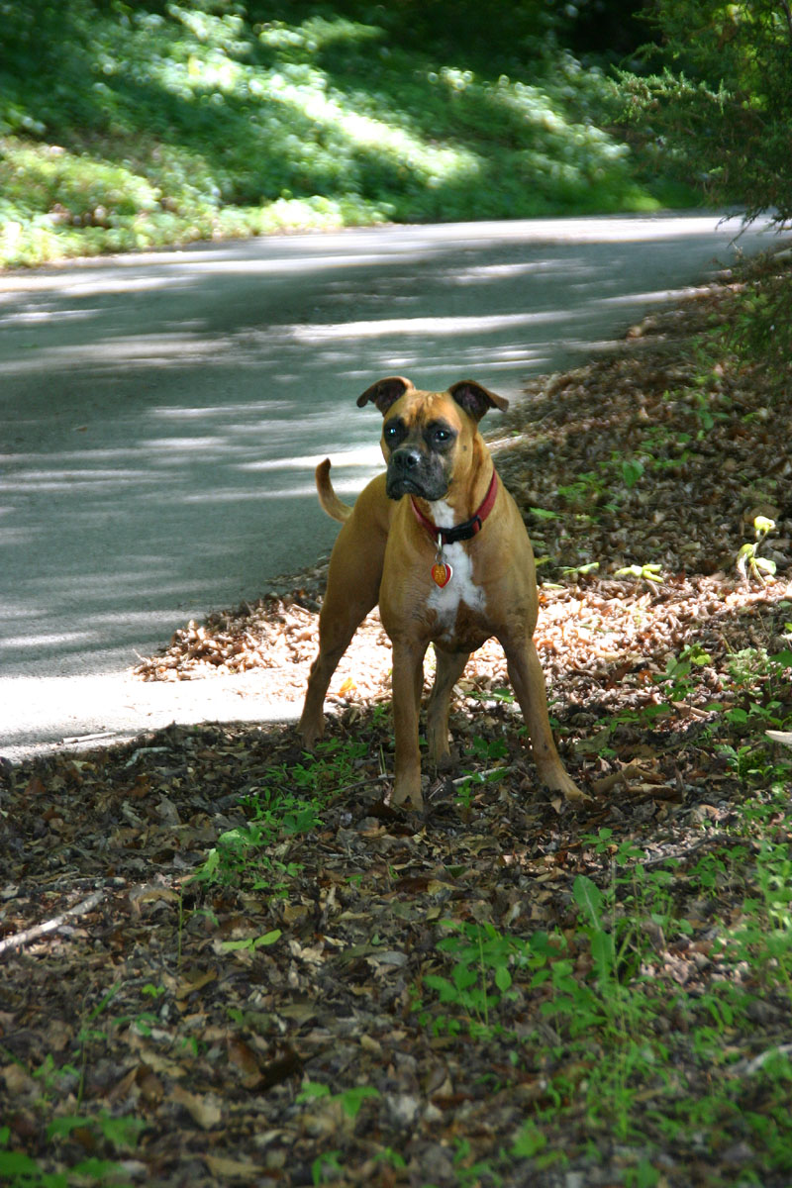
Image 5369: Molly On a Forest Road, Shepherdsville Kentucky -- "Are We There Yet?"
Day 34: Tuesday June 7 -- Shepherdsville Kentucky to Newport Tennessee (~300 miles)
Our day started early, though we did not expect to complete the 500+ mile long haul between Shepherdstown and Fort Mill SC. Southern Kentucky and northern Tennessee are quite mountainous. When we stopped for gas at mid-morning, a casual comment by an auto mechanic confirmed that it might be unwise for us to push hard on these roads. "I hope you guys have a good spare for the trailer. One of your tires doesn't look so good."
I looked closer at the road tires. The new radials were fine, but the two remaining older tires had very little remaining tread and might not make it through the mountains we still faced. It was clearly time to change them. So as we got close to Lexington Kentucky, we started looking for a tire store. Two hours after we rolled into Versailles (which the locals pronounce "ver-says" rather than "Fair-Sigh"), we were on our way again. As Maren drove, I researched our overnight stay in real time and phoned ahead to the next and last campground of our trip.
Our last KOA campground was up to the same overall standard we had found in this chain to the West. The camp had attracted a large tenting crowd of families with kids, so the pool was filled to overflowing (not the fault of the camp managers). But the grounds were deeply shaded by old trees. Beautiful flowers decorated beds around the camp offices and near the front gate. Molly and I had another good walk before the three of us settled in for a quiet night.

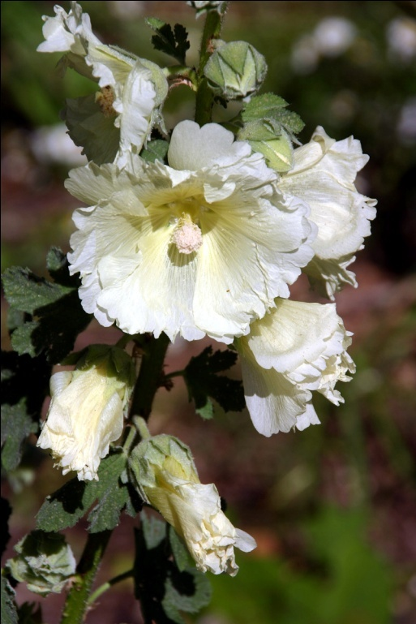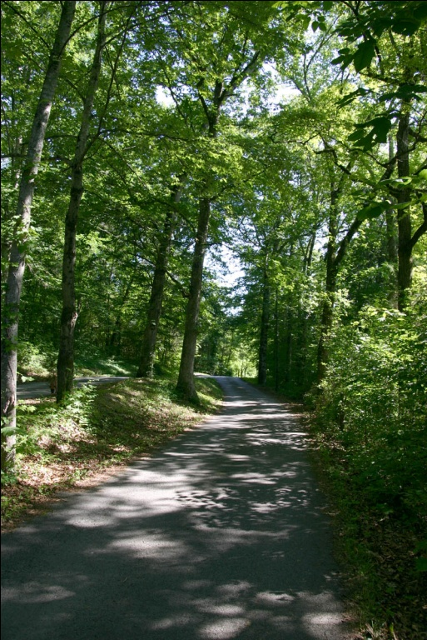
Image 5358: White Hollyhocks in the Great Smoky Mountains
Image 5367: Forest Road in the Great Smoky Mountains

Day 35: Wednesday June 9 -- Newport Tennessee to Fort Mill South Carolina (~194 Miles)
What can one say about the last day of a 35-day American Journey? For us, it was at least mercifully short. We arrived home about noon after a pleasant morning drive through the rolling greenery of the Smoky Mountains of Tennessee and North Carolina, on US Route 40. Our house still stood atop its hill. Nearby trees that had been in first leaf when we left on May 6th were now fully leafed out on June 8th. The temperature was in the 90's... but we were home.

A Photographic Footnote to Our American Journey
We saw and walked through quite a number of beautiful places in America during our first adventure in long distance recreational trailer touring. More fundamentally and deeply, we experienced a few nuances of what it means to be an American in the great Western Interior of the US -- a feeling that simply can't be fully conveyed unless one has "been there". We came away from these experiences with a deeper appreciation for this country and for some of the historical traditions and current problems of its people.
Wyoming taught us a bit about the implications of a "real" winter. The South Rim of the Grand Canyon and the Hoodoo columns in Bryce Canyon stunned us to silence even as we searched for some word larger than "wow" to describe these places. We saw traces of settlers, cowboys and Indians, saints and sinners, characters and places of myth that stood a little larger than contemporary life.
Though some of these places and people seemed to affect us more than others, we could not in honesty identify any single picture that was our "favorite" or the "best" of the many that I took. Still, I looked for pictures that might in some way have summed up the 35 days of our American Journey. And perhaps I found a few. The following three photos were taken near the home of Maren's Aunt Edda -- nominally the "destination" which first tempted us to consider taking Molly coast-to-coast in a travelling house, to meet a grand and loving friend. Though taken the year before we embarked on this adventure, they speak to something of our goal: the broad and sometimes tempestuous Pacific Ocean. It was a goal that we reached, only to discover and appreciate other way stations that we hadn't quite anticipated. And it is a place like several others on this American Journey, to which we hope to return in the future.

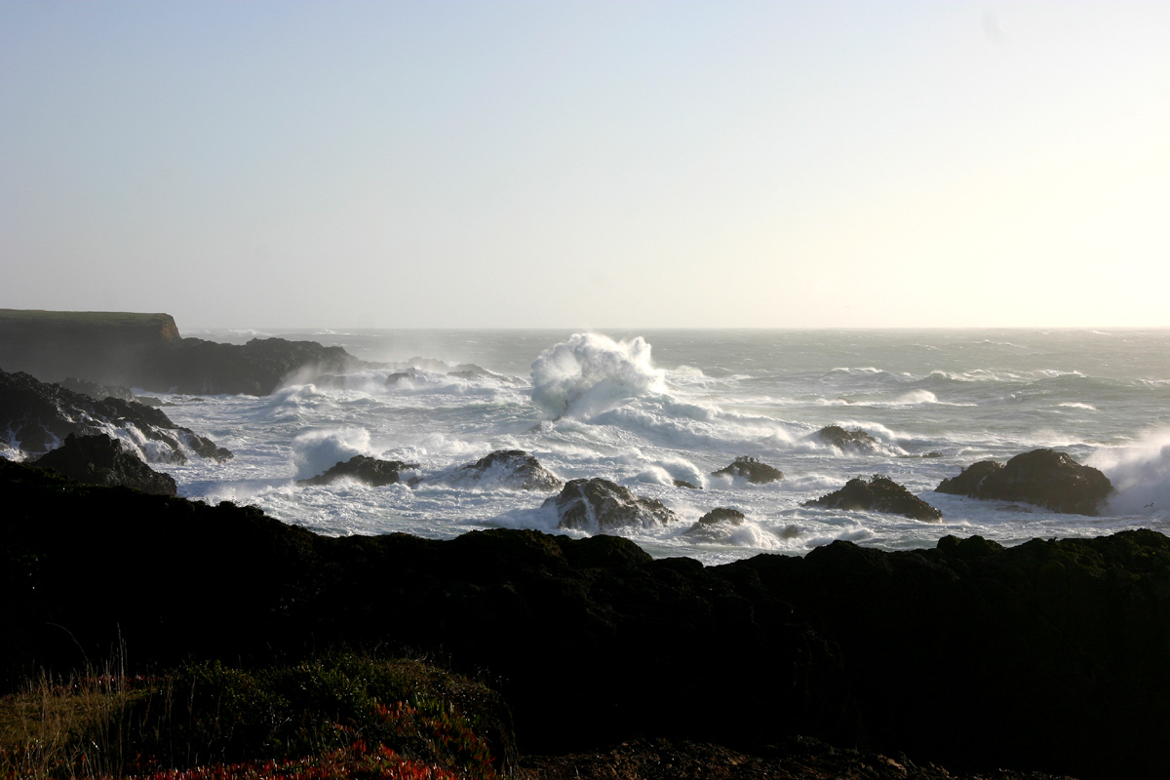
Image 0945A: Stormy Mendocino Coast (November 2009)
[The cliffs in this picture are about 50 feet high above the beach]
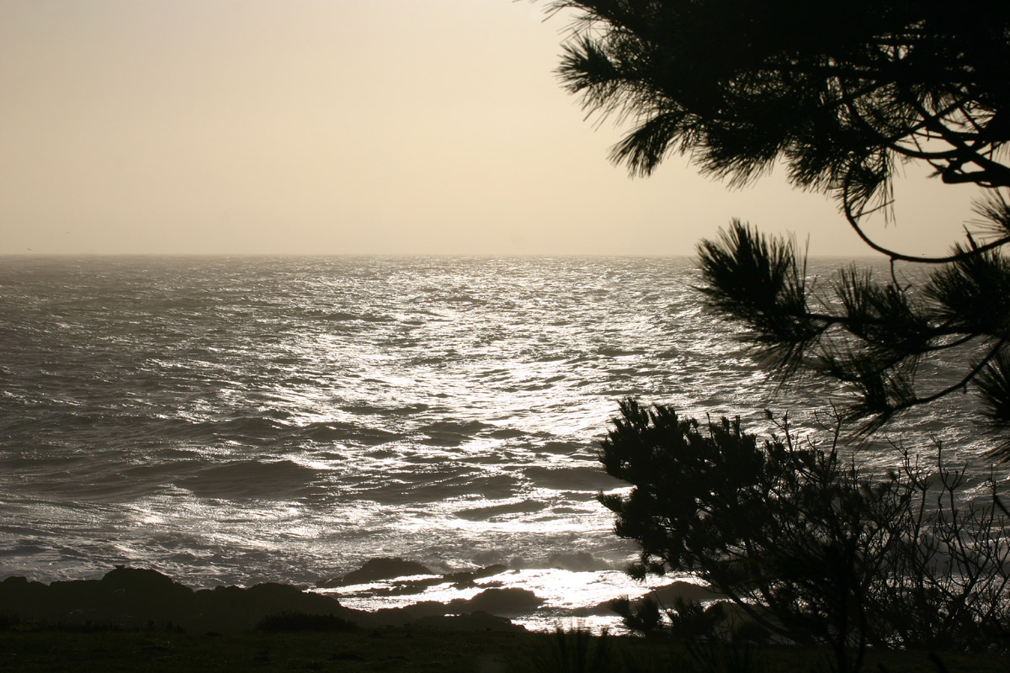
Image 0948A: Bronze Sea -- Mendocino Coast (November 2009)
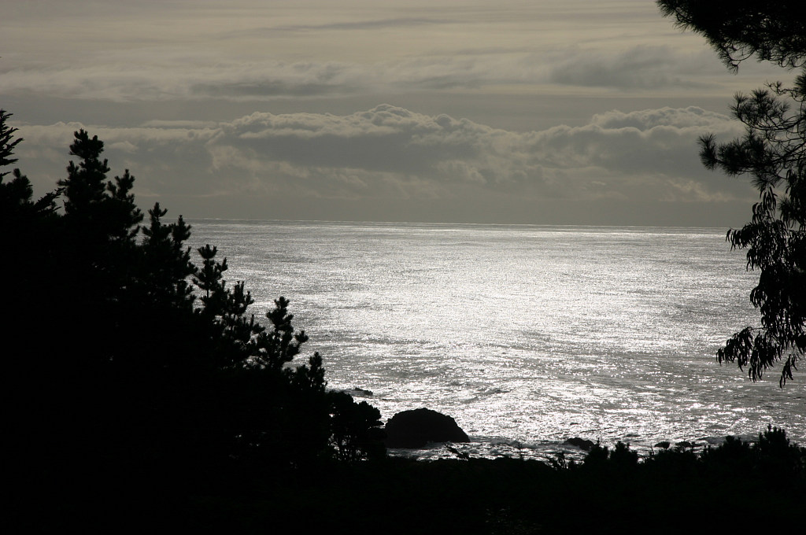
Image 0950A: Silver Sea -- Mendocino Coast (November 2009)

